Lab setup for RESTful Webservices - JAX-RS

**Hardware Requirements**

* **CPU:** i Core 3 or higher (64 bit hardware platform)
* **Hard** Disk: 250 GB Minimum
* **OS:** Windows 10 (x64 bit)
* **RAM:** 8 GB Minimum
* **Others:** Keyboard, Mouse, LAN Connectivity
* **Internet:** Wi-Fi enabled with Good internet connectivity (More than 5MBPS)
* **Permission:** Admin rights to download and install software’s & permission to download maven dependencies & plugins in VS Code

**Software Requirement:**

* JDK 17 or later
* Eclipse IDE for enterprise developers (64 bit)
* VS Code
* Tomcat Server 9

**Note:** All the above software’s are free

JDK 17 Downloading & Installing Steps

1. Visit the below link

<https://www.oracle.com/java/technologies/javase/jdk17-archive-downloads.html>

1. Scroll down to locate Java SE Kit 17.0.1.0

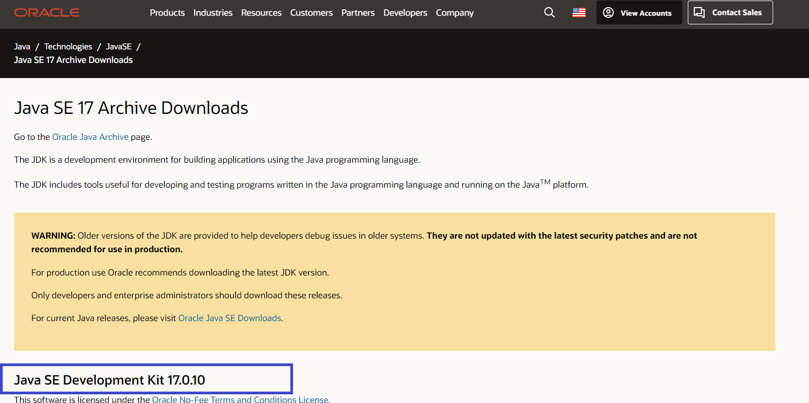

1. Scroll down to find Windows x64 MSI Installer

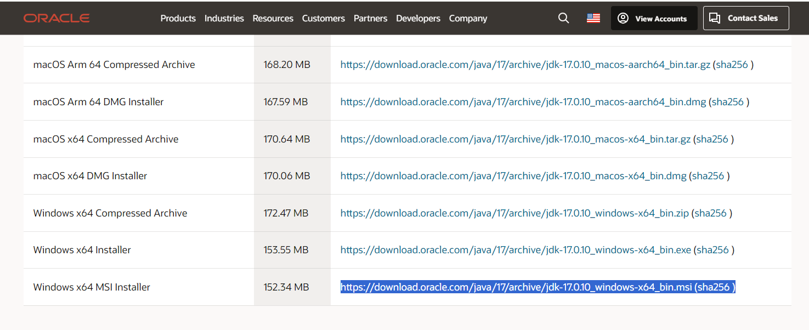

1. Now click on the Highlighted link <https://download.oracle.com/java/17/archive/jdk-17.0.10_windows-x64_bin.msi>
2. Above link downloads the JDK Wait for the download to complete
3. Locate the downloaded file JDK-17.0.10_windows-x64_bin & double click

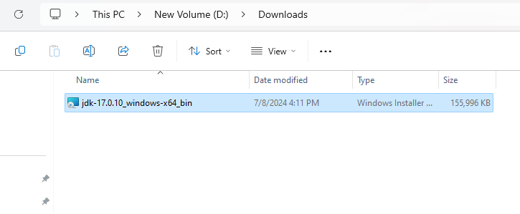

1. Double click on the JDK-17.0.10_windows-x64_bin file which starts installing and shows the below dialog

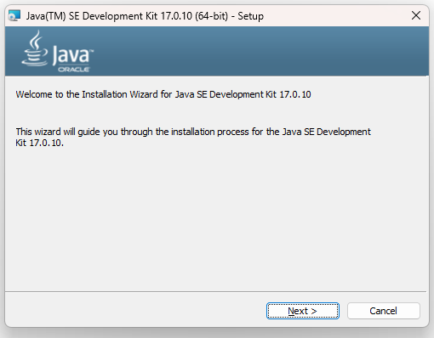

1. Click Next

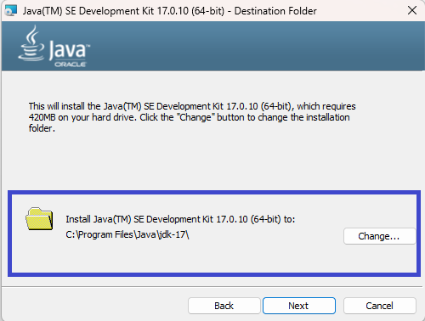

1. Click Next and wait, you will get a installation successful dialog as below

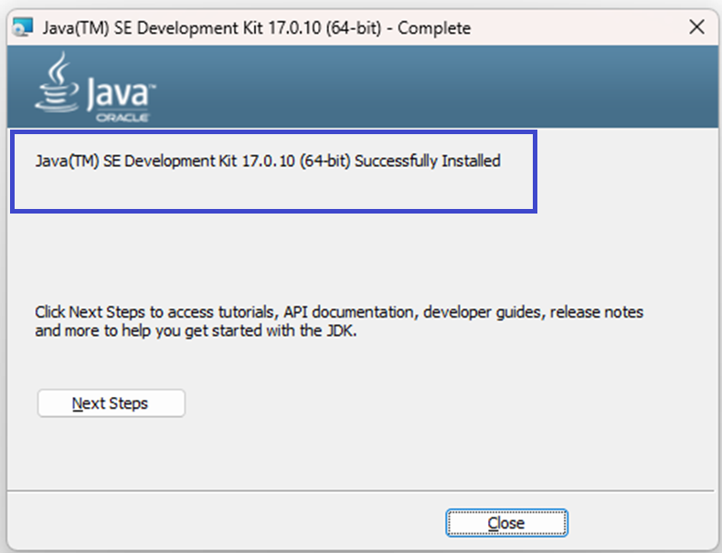

1. Now you click on Close.
2. Below folder will be created in **C:\Program Files\Java**

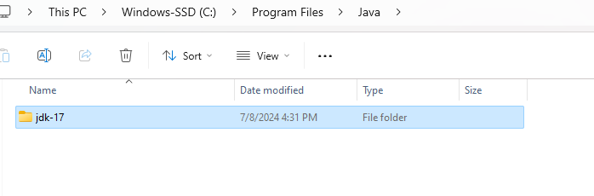

1. Add **C:\Program Files\Java\jdk-17\bin** to the system path
2. Go to File Explorer & Right Click on This PC and navigate to the Properties

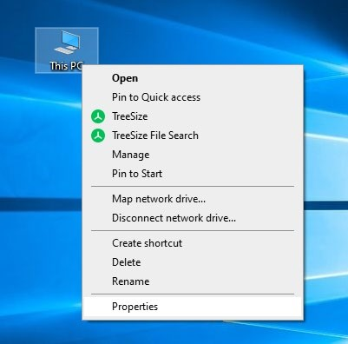

1. You will directed to the System Settings, there you will see Advanced System Settings as below.

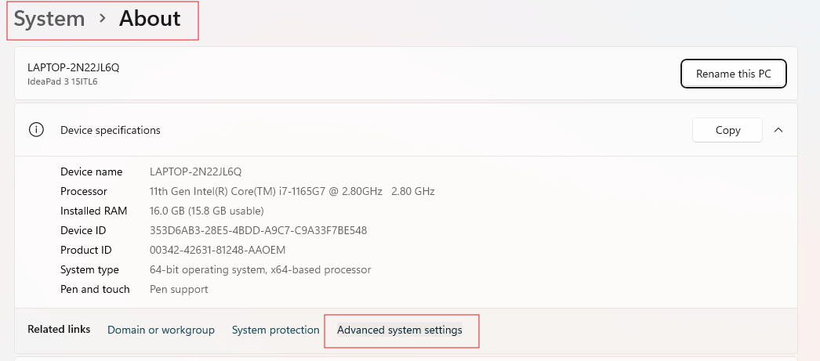

1. Click on the Advanced System Settings & you will see below dialog

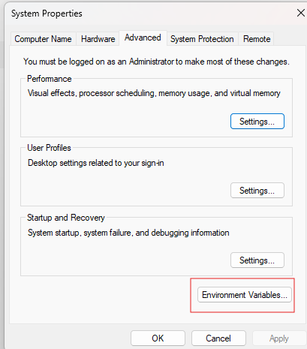

1. Click on the Environment Variables, you will get below dialog

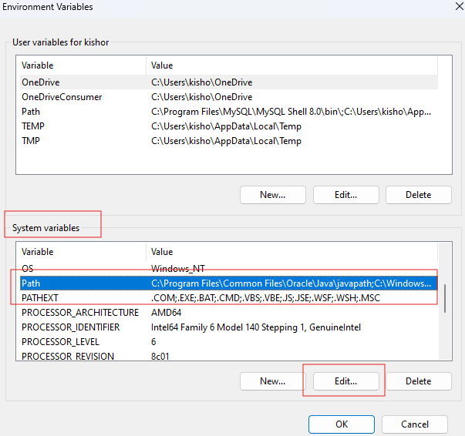

1. Select Path & Click on Edit button in the System Variables, you will get the dialog as below

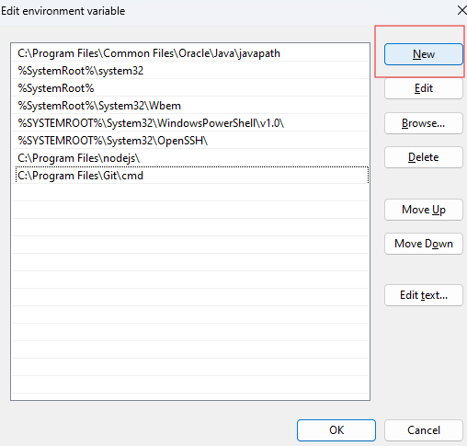

1. Click on you get an empty text box which looks as below

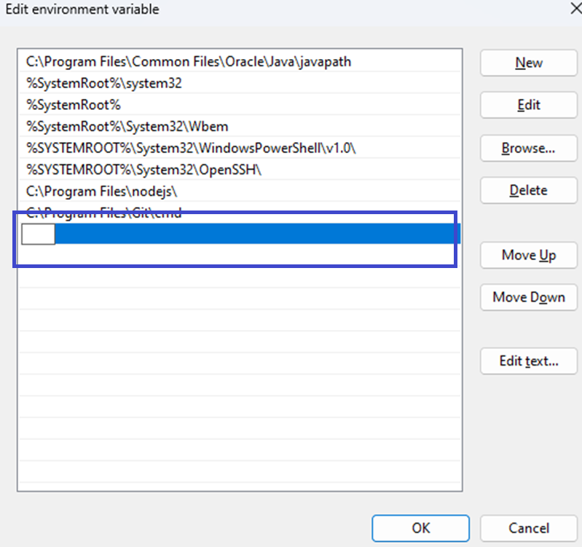

1. Paste the path of **C:\Program Files\Java\jdk-17\bin** in it

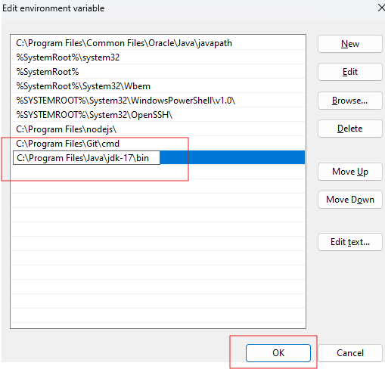

1. Click Ok, and again click Ok to close all the windows which were opened by clicking “Advanced System Settings” then you need to click Ok on other dialog boxes.
2. Open the command prompt and run the command one by one
   1. javac -version
   2. java -version
3. You will see the version numbers as below

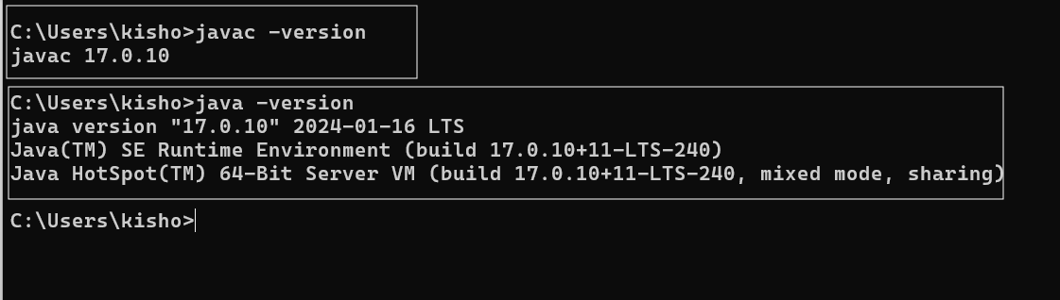

Note: If you see command not found on javac or java you need to check their spellings or redo the steps explained from point no 12.

Eclipse Downloading & Using Steps

1. Visit the below link

<https://www.eclipse.org/downloads/packages/release/2023-03/r>

1. You will see Eclipse IDE for Enterprise Java & Web Developers as below, click on the Windows x86_64

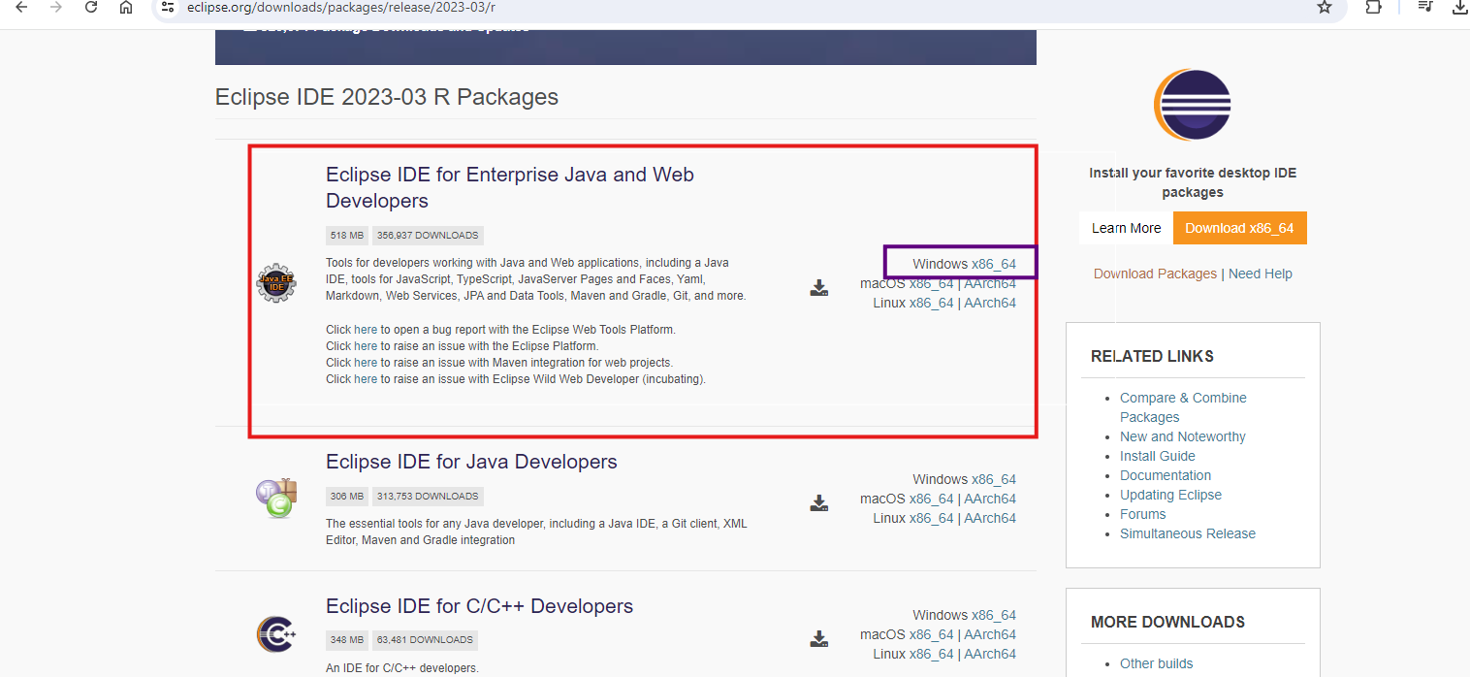

1. It starts downloading a zip, wait for the download to complete.
2. Once the download is complete you will see a zip as below



1. Right click on that zip and extract the folders so that you will see a folder as below once the extract is done.



1. Open the extracted folder and you will see the below eclipse file as shown below

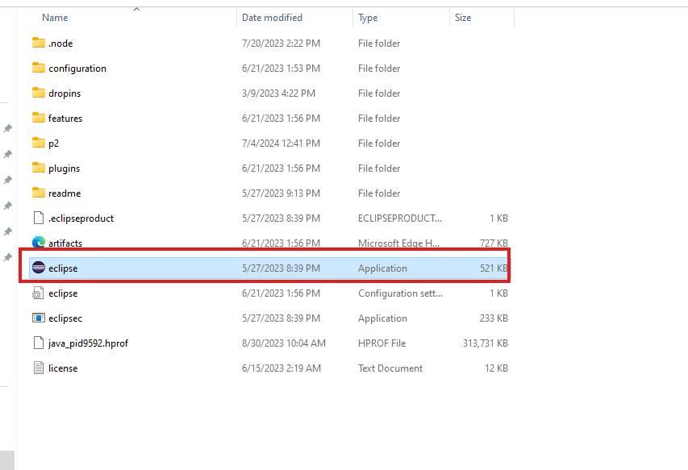

1. Double click on that eclipse file you will see a dialog box as below

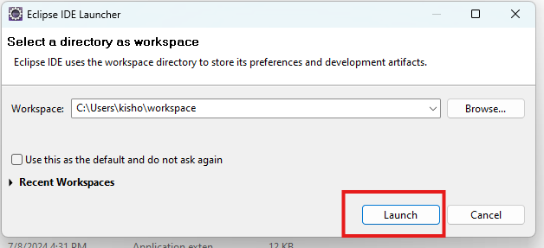

1. Click on eclipse you must be able to see the eclipse perspective as below

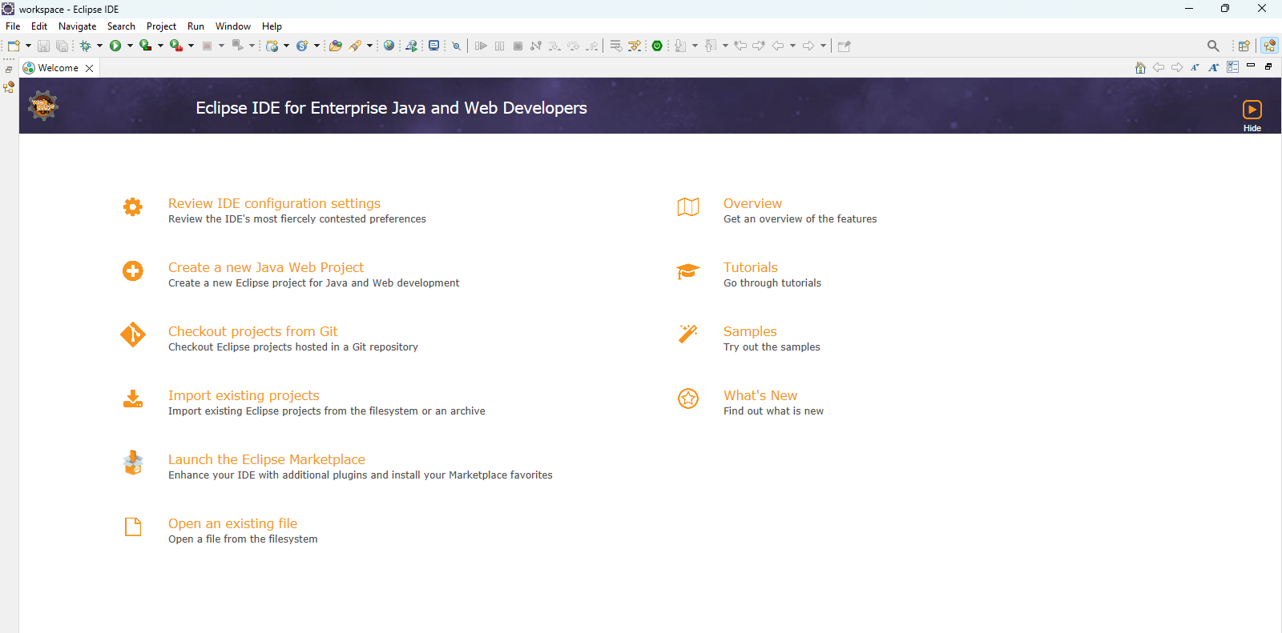

Downloading VS Code

1. Visit below link

<https://code.visualstudio.com/download>

1. Select .zip under Windows & click on x64

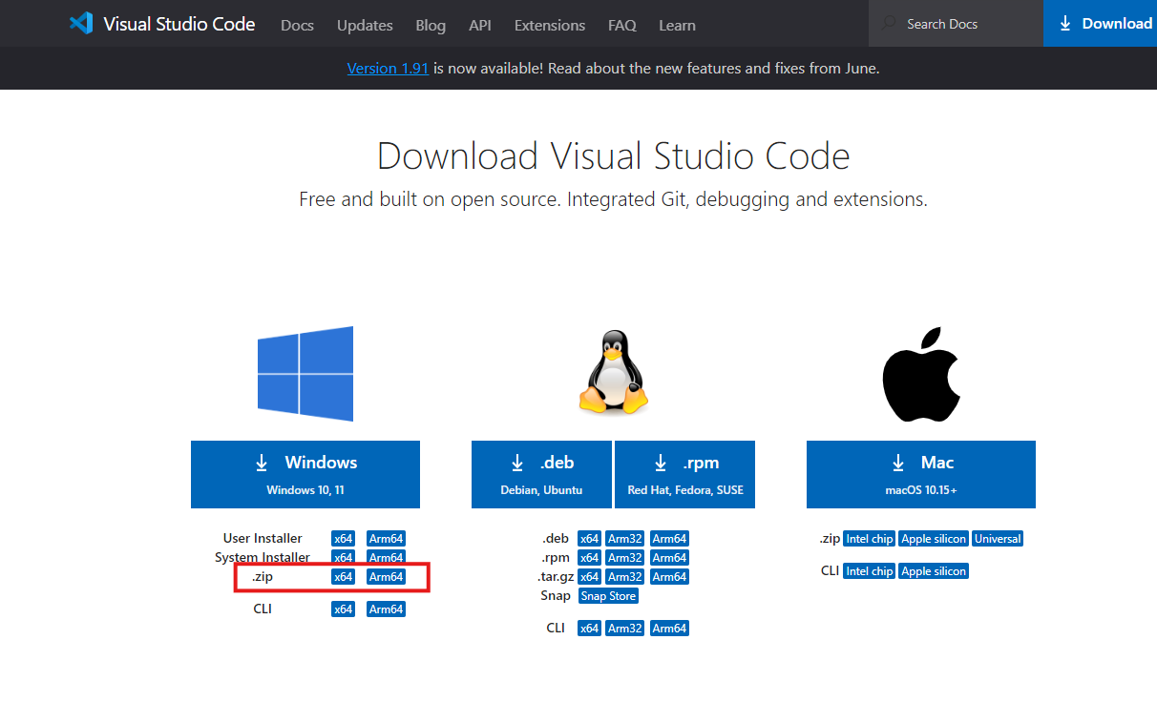

1. It starts downloading the zip, wait for the download to complete



1. Unzip the file in Desktop or Downloads folder

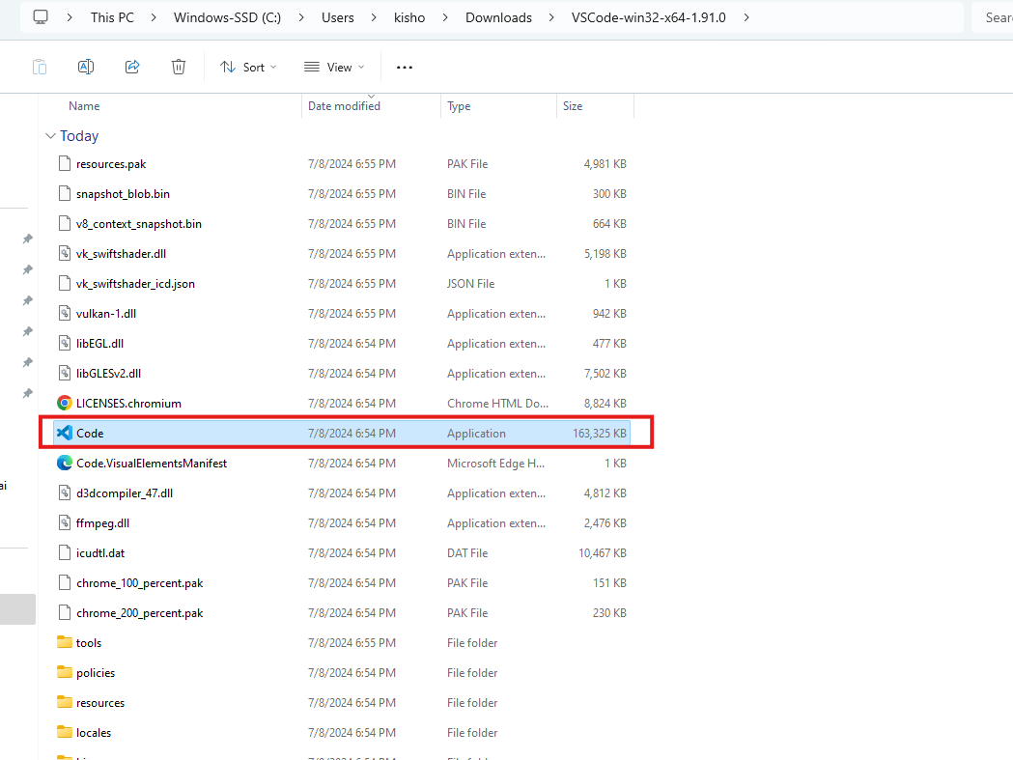

1. Double click on the Code icon

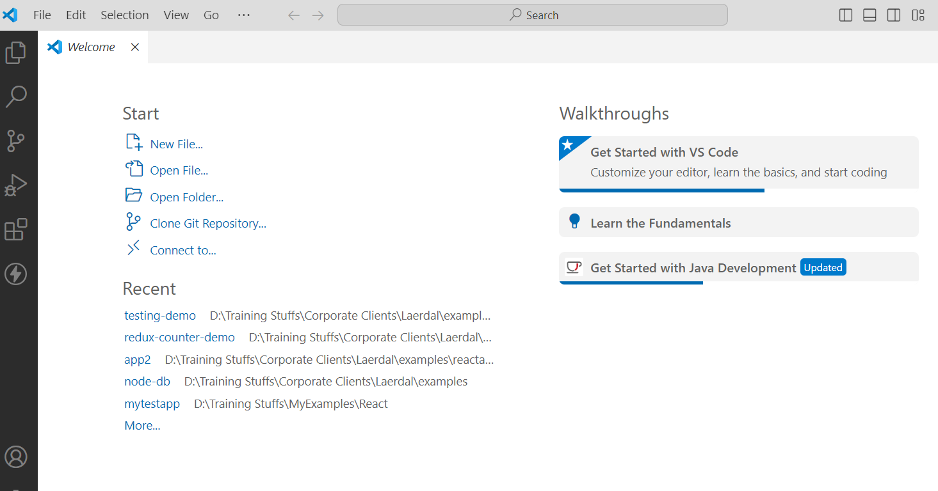

1. VS Code editor opens

Tomcat Download

URL:

<https://tomcat.apache.org/download-90.cgi>

Visit the above link and locate Tomcat 9 in the downloads section

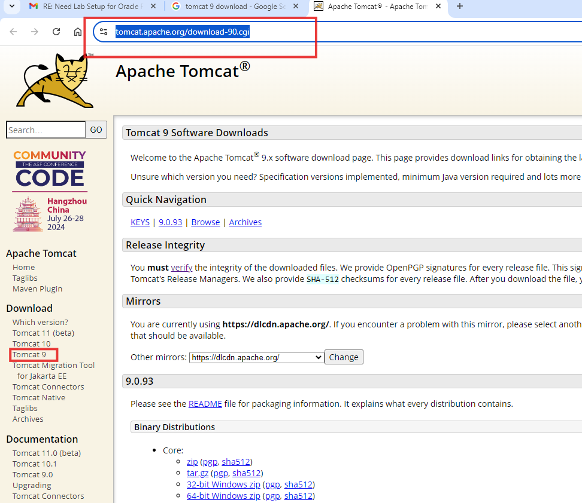

Scroll down the page and click on the 64 bit windows zip

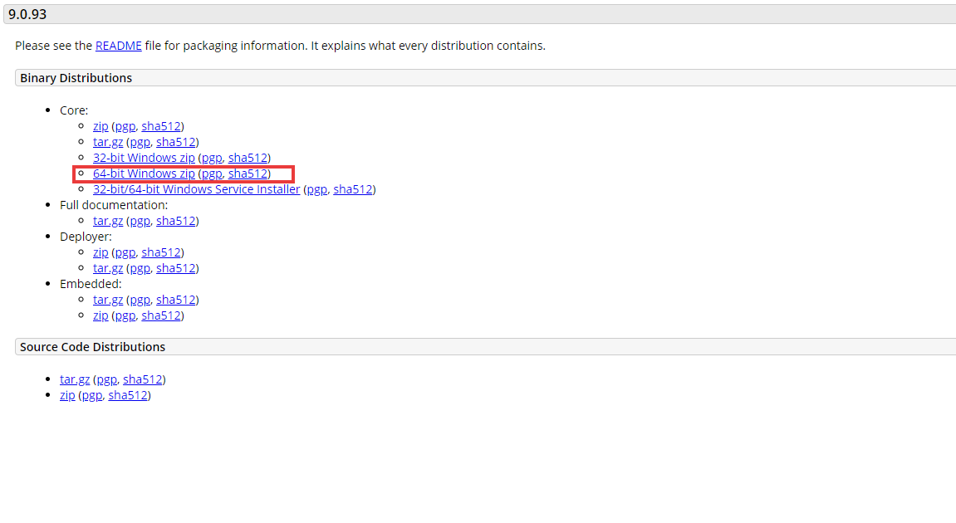

Just remember the location where the zip file is downloaded